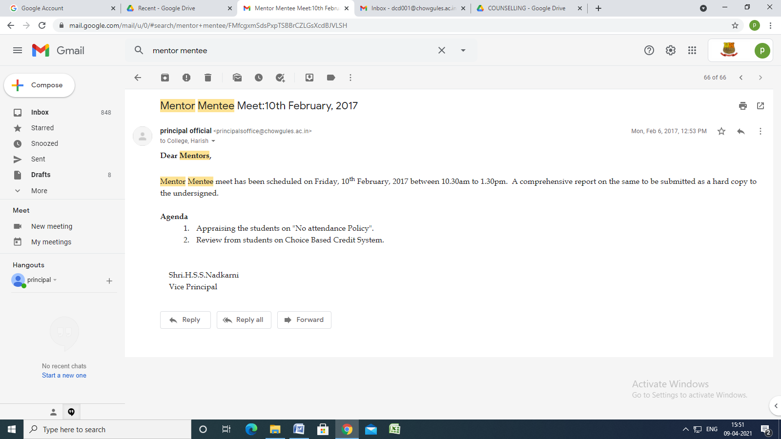Mentor Mentee Meet:10th February, 2017
principal official <principalsoffice@chowgules.ac.in> | Mon, Feb 6, 2017, 12:53 PM
to College, Harish

Dear Mentors,
Mentor Mentee meet has been scheduled on Friday, 10th February, 2017 between 10.30am to 1.30pm. A comprehensive report on the same to be submitted as a hard copy to the undersigned.

Agenda
1. Appraising the students on "No attendance Policy".
2. Review from students on Choice Based Credit System.

Shri.H.S.S.Nadkarni
Vice Principal

